Software Requirements Specification
for
READ
Version 1.0

Prepared by
Group No: 6
Ishrat Jahan Ananya | 1631636042 | ishrat.jahan16@northsouth.edu
Humayan Kabir | 1511089042 | humayan.kabir@northsouth.edu
Mehran Siddiqui | 1822107642 | mehranalvin@gmail.com
Aiaj Uddin Bhuiyan | 1621696042 | aiaj.bhuiyan@northsouth.edu

Instructor: | Dr. Nabeel Mohammed (NbM)
Course: | CSE 327
Section: | 1
Date: | 04/02/20
Contents
Contents ii
Revisions ii
1 Introduction 3
1.1 Document Purpose 3
1.2 Product Scope 3
1.3 Intended Audience and Document Overview 3
1.4 Document Conventions 3
1.5 References and Acknowledgments 3
2 Overall Description 4
2.1 Product Overview 4
2.2 Product Functionality 4
2.3 Design and Implementation Constraints 4
2.4 Assumptions and Dependencies 4
3 Specific Requirements 4
3.1 External Interface Requirements 5
3.2 Functional Requirements 5
3.3 Use Case Model 6
4 Other Non-functional Requirements 6
4.1 Performance Requirements 6
4.2 Safety and Security Requirements 6
4.3 Software Quality Attributes 6
5 Other Requirements 7
Appendix B - Group Log 9

Revisions
Version | Primary Author(s) | Description of Version | Date Completed
1 | Ishrat Jahan Ananya |  | 04/02/20

Introduction

Document Purpose
The purpose of this document is to present a detailed description of READ. It will explain the goals of the project, the features implemented, the navigation of the user interface and finally the limitations and future-proofing aspects of this project.

Product Scope
The objective of the project is to create a web application to manage course materials for a class, track user’s face when reading study materials and provide important statistics based on it. There will be students’ and teachers’ portals, where the students can enroll in many courses and track their assignments and schedules all in one place. The teachers can share study materials and keep record of who actually read through everything using facial recognition and eye tracking and generate statistics for every individual class.

Intended Audience and Document Overview
This document is intended for the professor, project managers and developers who will find the list of functions and requirements needed for developing this application.
This document does not illustrate any specific points of failure and uses some technical terms, so it may be less useful to testers and business managers. Section 3.2 of this document contains detailed description of the functionalities mentioned in section 2.2. Use case model is illustrated in section 3.3. The reader can jump to the relevant parts of the document as necessary.

Document Conventions
This document follows the IEEE formatting requirements. Each section and subsection have been divided and numbered to distinguish them. Special terms and comments are in italics.

References and Acknowledgments
This document makes no explicit references apart from the use of the IEEE format for writing the document.

Overall Description

Product Overview
READ is designed to be a web application for teachers and students. It acts as a powerful tool for teachers to maintain different classes of pupils and the course materials shared. READ allows teachers to check and verify (using facial recognition and eye tracking) who has read and completed their assigned tasks and aggregate statistics of class performance based on the records.
The front end will be a series of web pages and the back end will consist of a database system and a web server to run the program. Webcam will be accessed to track the users’ face.

Product Functionality
1. Student and Teachers portals to track multiple courses
2. Detect students’ faces when a reading material is viewed
3. Identify if students’ eyes are open or close when reading material is viewed
4. Record time spent on each study material
5. Generate weekly reports of students’ activity/progress for teachers

Design and Implementation Constraints
As this product is being implemented as a web app, there will be little design or implementation constraints in terms of the webpages. Major implementation constraints may include lack of time to deliver set goals and successfully implementing facial recognition and eye tracking technology.

Assumptions and Dependencies
This product relies on any API used for the facial recognition and eye tracking technology that might affect its functionality.
Additionally, the website is being hosted on a local machine and may be shifted to a third-party web provider. If this is done so, the uptime of the website (the time during which it is accessible) may depend on the third-party.

Specific Requirements

External Interface Requirements

User Interfaces
The user interface will be several webpages each for a different task. The layout will be created using the help of any existing template.

Registration and Login page - allows the user to register and create an account in the web application. If account already exists, the user will log in to their respective accounts.

Dashboard page - the main page that will hold each user’s personal information and record of number of classes enrolled in. This includes a side menu bar that links to other pages.

Classroom page - this page holds all the course materials or assignments of a specific class posted by a teacher and can be viewed by both students and teachers.

Statistics page - this page can only be accessed by the teacher to see detailed information of class performance.

Hardware Interfaces
This product does not require any hardware interface because it is entirely enclosed within the bounds of a web application.

Software Interfaces
The majority of the web interface will be written in Html, Css and JavaScript, and so will not require any specialized software to run other than an up-to-date web browser. Django will be used as the framework to handle the backend which includes the database system and run the program.
Additionally, a facial recognition API shall be used to meet the basic functionality of the product.

Functional Requirements
Functional requirements discussed in section 2.2 are elaborated below enlisting detailed requirements for every function.

Student and Teachers portals
There are 2 different options for user accounts - student’s account or teacher’s account. Each have different features available to them based on the type of account it is.
Requirements:
i. Registration panel with two different options (student or teacher) requiring a username and a password.
ii. Login panel for users to login given they already have an account.

Facial Recognition and eye tracking

User will be prompted to allow webcam access so that their faces can be identified when reading a course material. Further more the users eye movements will be tracked to identify if they were actively reading or not. The time to read a document will also be recorded in the back end.
Requirements:
i. every time a document is opened, activate webcam to detect face and eye movements and verify if the document has been read.
ii. record the result in a table

Generating useful statistics
For the teachers account, the teachers have the option to view statistics in the form of charts or graphs of students’ performance of each class. This includes average time to spent on reading course materials, record of which student viewed or didn’t view the assigned material, comparisons of different sections of the same class.
Requirements:
i. button in teachers’ dashboard to statistics page
ii. show class performance for each course in a tabular form.

Use Case Model
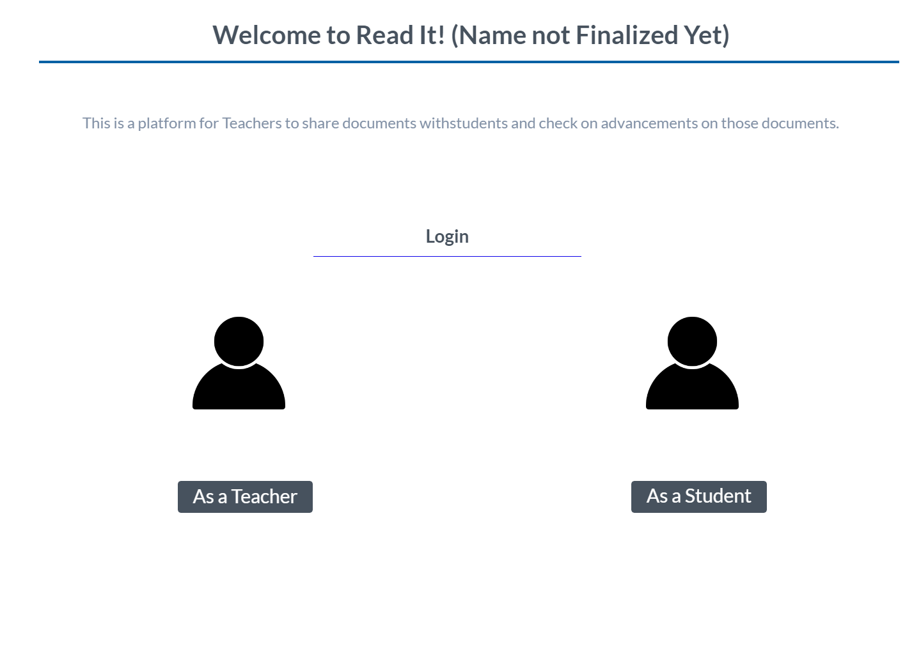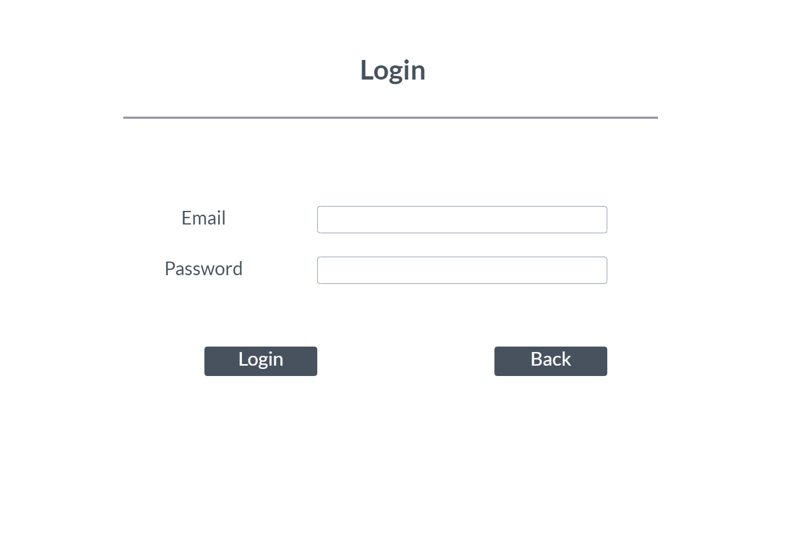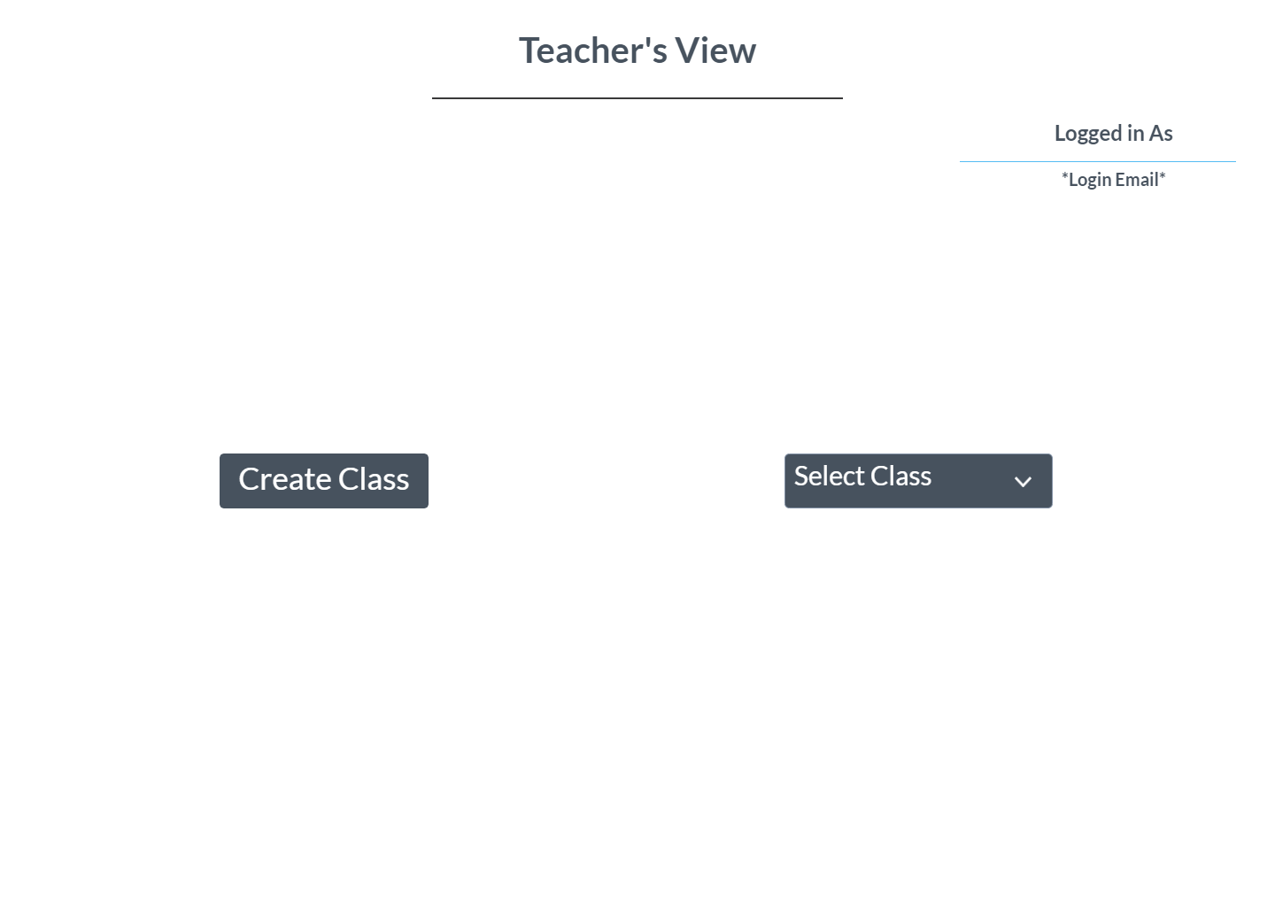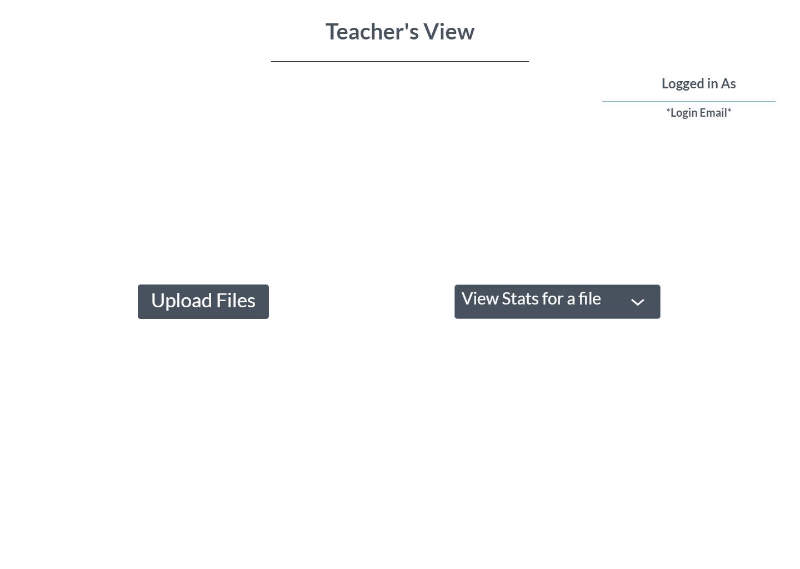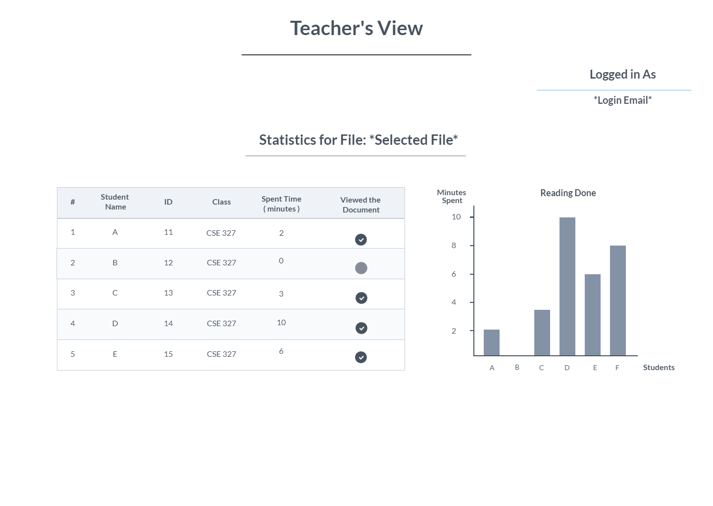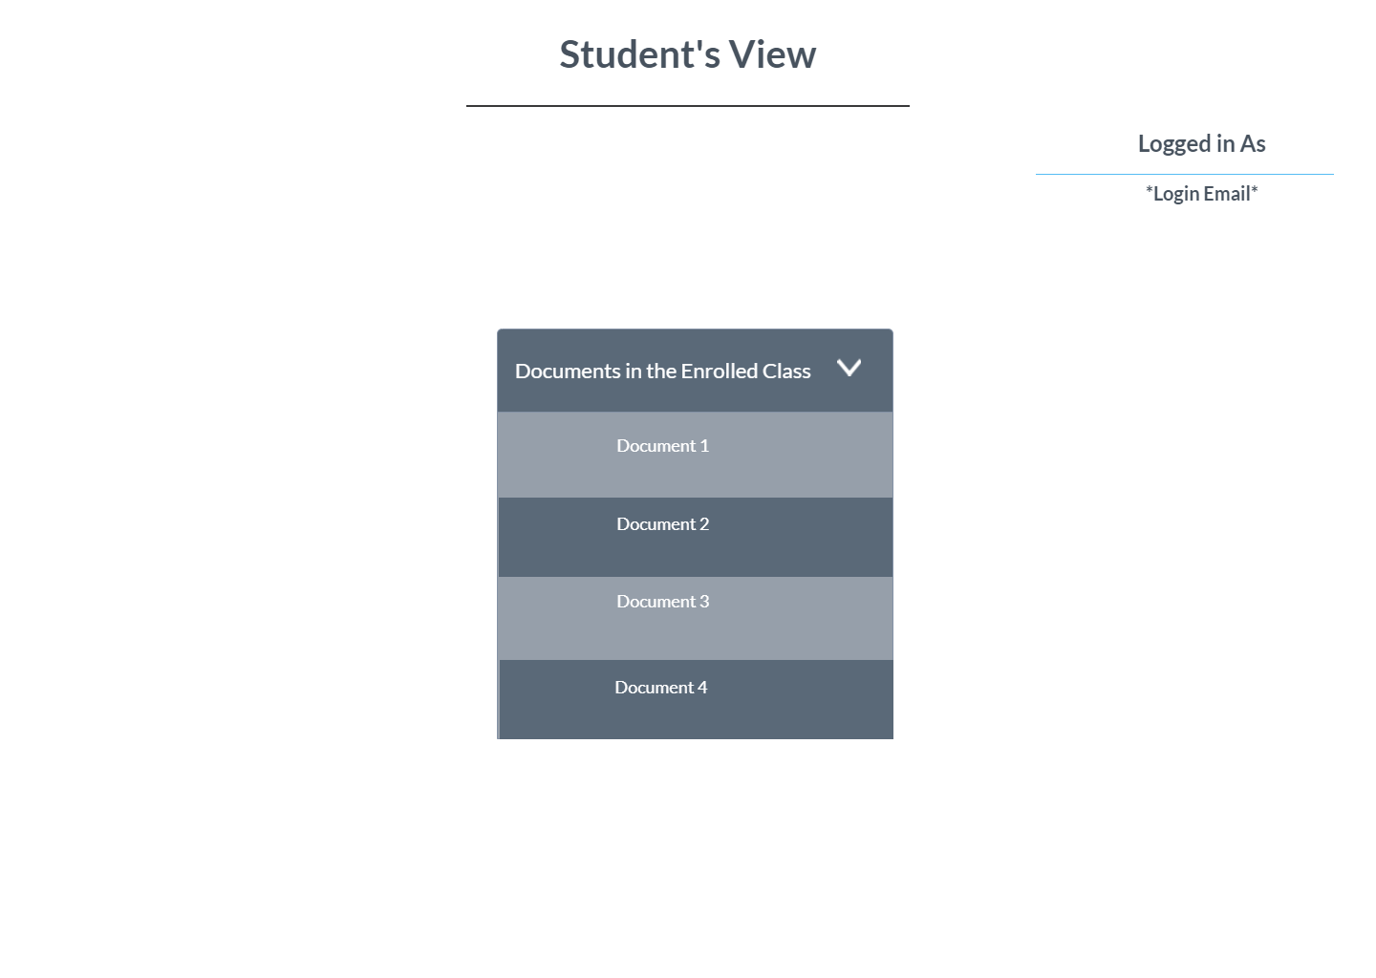

U1 – Create classroom
Actor - Teacher
Purpose – To create a classroom where students will be added and files can be uploaded
Priority - High
Preconditions – User must have an account
Post conditions – user will have a classroom created and a link to that page
Flow of Events
  - User requests to create a new class
  - User fills in information and creates a new class to add students in.

U2 – Upload files
Actor - Teacher
Purpose – upload files/documents for the students to read
Priority - High
Preconditions – User must have an account and a class created
Post conditions – user will upload any document in the classroom page
Flow of Events
  - User requests to upload a file
  - User selects the document from the options and clicks enter
  - The new document is displayed in the classroom page

U3 – View statistics
Actor - Teacher
Purpose – teacher will be able to view statistics based on students’ performance
Priority - medium
Preconditions – User must have an account and a class created. User must have uploaded files
Post conditions – statistics page will show graphs and charts generated from students’ performance
Flow of Events
  - User requests to view statistics page
  - User selects different charts/graphs to view in details

U4 - enroll in class
Actor - Student
Purpose – student will join any class created by a teacher
Priority - high
Preconditions – User must have an account
Post conditions – User will be added to a classroom
Flow of Events
  - User requests to join a class
  - User is asked for a unique code
  - Upon entering user can see all files uploaded by the teacher

U5 – View Documents
Actor – Student, Teacher
Purpose – teacher and students can view the documents once its uploaded
Priority - high
Preconditions – User must be enrolled in a classroom, there must be files uploaded
Post conditions – students’ face will be tracked and recorded
Flow of Events
  - Students view a document
  - Students face is tracked using facial recognition to check if they are reading
  - The time to finish reading is recorded
  - Teacher is notified about who has read through the given course material

Other Non-functional Requirements

Performance Requirements
The website should be efficient on memory and loading times. Every page must load within a second.

Safety and Security Requirements
The website, once deployed on a web server rather than a local host, should get an HTTPS connection certificate, in order to ensure when a user enters the website, they know their data is secure and the connection is encrypted.

As this website will contain personal data regarding its users, security must be maintained. Users should be cautioned from putting sensitive data anywhere, and their passwords will be stored in hashed form in order to prevent brute-force access to their accounts. Users and Administrators should also be discouraged from sharing their account credentials, to prevent data breaches.

Software Quality Attributes
The main requirements here is that the system is straightforward and easy to use, therefore having good usability.
The main security concern here is user’s login information so a proper login mechanism must be used to avoid hacking.

Other Requirements
1.Federated User Credentials

In addition to making their own accounts whose credentials are stored in the project’s database, users will have the option of using their Google accounts to log in. As Google is one of the largest and widely used platforms on the internet. This would reduce the hassle for a new user of the website and improve ease of access.
Again, security must be maintained on both the developers’ and users’ side, in order to ensure the users do not suffer any security breaches regarding their Google account.

Appendix B - Group Log
Two short group meetings were conducted to discuss the requirements of the project, share related information gathered to complete the task and set an achievable goal.

